HTML 🡺 hypertext markup language
🡺 data presentation and UI designing (sign up, login, registration, search form…)
🡺We can design static web pages

CSS 🡺 Cascading Style Sheets
🡺 Used to change look & feel of webpage (html elements)
🡺It helps to present data more effectively, attractively & animations

JavaScript 🡺it provides logical support to html pages
🡺 its works like as back-end for html/css
🡺used to develop responsive web pages

Html, css & JavaScript are web technologies, these techs are used to develop web applications.

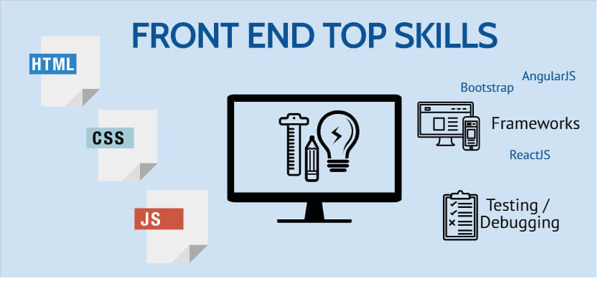

WHAT IS APPLICATION OR SOFTWARE?
Application is an Automation process of manual business operations (human being work) by using a programming language.

TYPES OF APPLICATIONS OR SOFTWARES
We can create an application or software in following flavors:
- Desktop: The applications which are installable in local systems are called desktop applications.
- Mobile: The applications which are installable in mobile phones or tablets downloaded from play store for android and apple store for ios.
- Web: The applications which are deployable in any server and can be accessible from any location using a browser.

WHAT IS WEB APPLICATION?
Web applications are network enabled applications. We can deploy any web applications in servers and we can access them over the network using server ip address and application name.
In computing, a web application is a client–server software application which the client (or user interface) runs in a web browser and it contains web documents in the form electronic pages (web pages).

A web application typically contains following three layers:
Presentation layer is a user interface (views) which are accessible from any web browser.

Business layer is a server-side program which is nothing but automation of business rules. Client layer will interact with the business layer to persist data.

Data layer is database software where we can store client related data. Business layer will interact with the data layer.
HOW MANY TYPES OF WEB APPLICATIONS WE HAVE?
A webpage is an electronic page developed on HTML.
A web page is a group of elements.
Collection of WebPages or web documents is called web application (website).

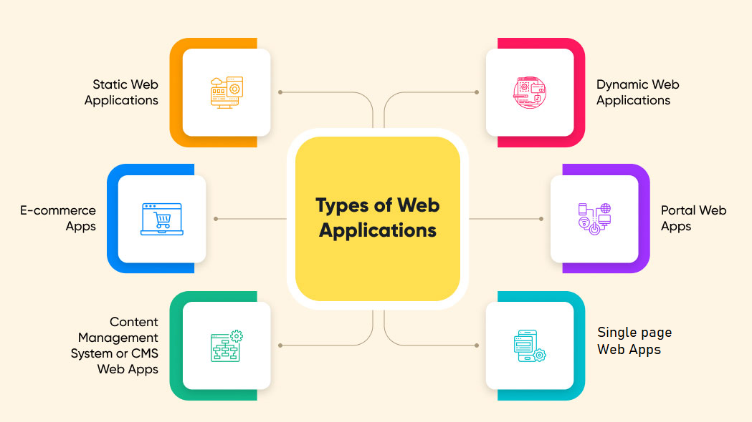

STATIC WEB APPS:
- The static web app directly delivers the content to the end user’s browser without fetching any data from the server. Most static web apps are known to be simple and effortless to develop across the web.
- HTML, CSS, and JavaScript are used to develop most static web applications.
- You can also add GIFs, animations, videos in static web apps.

DYNAMIC WEB APPS:
- A web application that generates the data in real-time based on the user’s request and server response, is known as a dynamic web application.
Eg: Facebook

SINGLE PAGE APPS:
- A single-page application runs entirely within a browser and doesn’t require page reloading.
Eg: Gmail

E-COMMERCE APPS:
- A web application that helps users electronically buy or sell goods over the internet is called an e-commerce web app.
Eg: Amazon

CMS APPS
A content management system (CMS) allows website owners to create, edit, and publish content, including images, text, and video, without involving a technical team. You can modify content through an admin panel without any knowledge of programming language.
Ex: Webflow, Wordpress

PORTAL WEB APPS:
- A portal web application is a website that provides access to many different pages and links.
- Portal web applications are often used for online shopping, news sites, blogs, and search engines.
- A portal web application's main idea is to browse through different content without leaving the site.
- Eg: telangana.gov.in
Network
Collection of computers interlinked together is called a network. First network name is ARPANET (Advanced Research Projects Agency Network). First protocol in the IT industry is FTP (File Transfer Protocol).

Internet
Internet stands for international networking.
The Internet is a network of connected computers. No company owns the Internet; it is a cooperative effort governed by a system of standards and rules. The purpose of connecting computers together, of course, is to share information.

A Brief History of the Web
The Web was born in a particle physics laboratory (CERN) in Geneva, Switzerland in 1989. There a computer specialist named “Tim Berners-Lee” first proposed a system of information management that used a “hypertext” process to link related documents over a network. He and his partner, Robert Cailliau, created a prototype and released it for review. For the first several years, web pages were text-only.

Tim Berners-Lee 🡺 WEB (1989-1990)
🡺 Html (HyperText Markup Lang)
🡺 WWW
🡺 W3C org
http

The World Wide Web Consortium
World Wide Web Consortium (called W3C) is the organization that oversees the development of web technologies. The group was founded in 1994 by Tim Berners-Lee, the inventor of the Web, at the Massachusetts Institute of Technology (MIT).
Tim Berners-Lee (WWW/HTTP), Cerf & Kahn (TCP/IP), Baran, Davies, Klein rock & Roberts (packet networking), Bob Metcalfe (Ethernet).

Server
A server is a computer or system that provides resources, data, services, or programs to other machines, known as clients, over a network/inet.
In theory, whenever computers share resources with client machines, they are considered servers.
a server stores all the data associated with the websites that are hosted by it and shares that info with all computers and mobile devices (like yours) that need to access them.

Client
A client is a device that connects to and uses the resources of a remote computer, or server.
Clients may use a desktop or a laptop or a tablet or a mobile phone or a TV or a car etc.
The device which is used by the user is called a “Client”.

User
The person who is working on/operating a client machine is known as User or end-user.
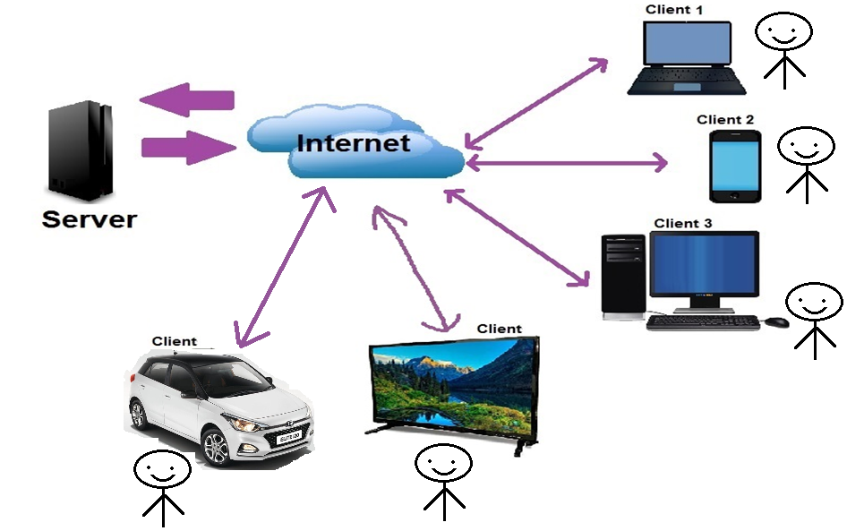

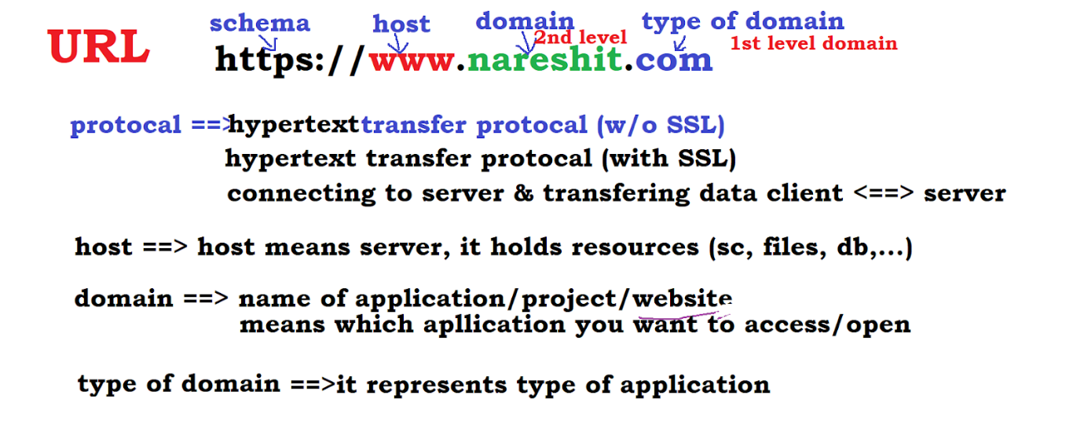

What is web browser?
It is client-side lightweight software installed in client machine. It sends http request from client to server; it takes http response from server.
Browser provides navigation among web pages, and browsers executes html, css, JavaScript files and displays output to user.

List of Computer Browsers:
Internet Explorer(1995), Opera(1995), Mozilla Firefox(1998), Safari(2005), Google Chrome(2008) etc…

Email: Electronic mail services. It is a free service to communicate with other internet users. Email is invented by Shabeer Bhatia. Sabeer Bhatia is an Indian entrepreneur who founded the webmail company Hotmail.com.
SMTP: Simple Mail Transfer Protocol. It takes care of delivering emails from one server to another.
MIME: Multipurpose Internet Mail Extensions. It exchanges different kinds of data.
Blog: It is daily updating website or webpage. Every post displayed in reverse chronological order.
Forum: It is an online discussion website to exchange resources each other.
Http: It is a transfer protocol to exchange hypertext documents in the world wide web.
Http(s): Secured transfer protocol to exchange hypertext documents with the help of SSL (cipher text).
Cipher text is encrypted text. Plaintext is what you have before encryption, and cipher text is the encrypted result. The term cipher is sometimes used as a synonym for cipher text, but it more properly means the method of encryption rather than the result.

